37.1: If 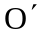 sees simultaneous flashes then O will see the 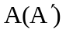 flash first since O would believe that the 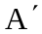 flash must have traveled longer to reach , and hence started first.

